11 May 2025

TO WHOM IT MAY CONCERN.

Dear Sir/Madam,

I am writing to cofirm that Leslie Nhongo, ID number **23-025208 Z 23,** is a staff member of Lowveld Academy . Leslie has been an invaluable asset to our team, bringing 17 years of extensive agriculture experience and a passion for teaching and sharing knowledge. His expertise in agriculture and teaching is complemented by his exceptional leadership, communication, and problem-solving skills, making him an effective team leader and a sought-after resource for colleagues in our science department.

If you require any additional information, please do not hesitate to contact me.

Sincerely,

**Sune Muller**

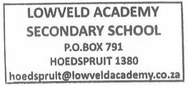**Head of Department for Science Department - Lowveld Academy**

**sune@lowveldacademy.co.za**

**+27828152642**